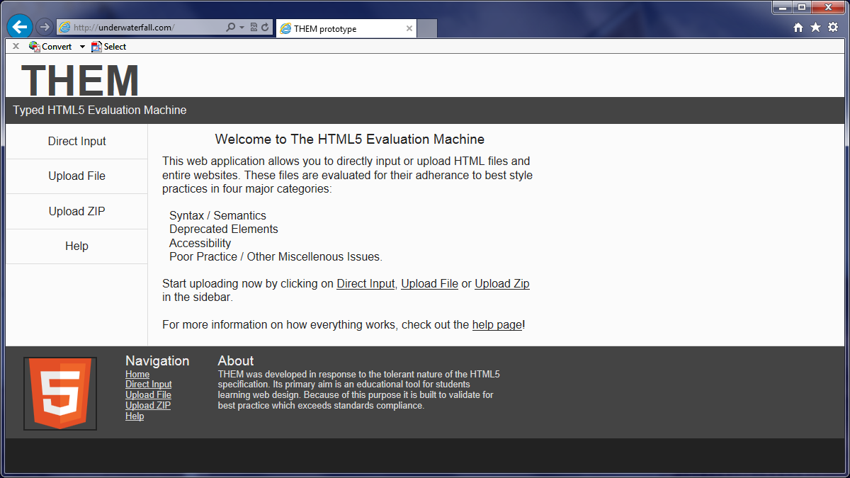
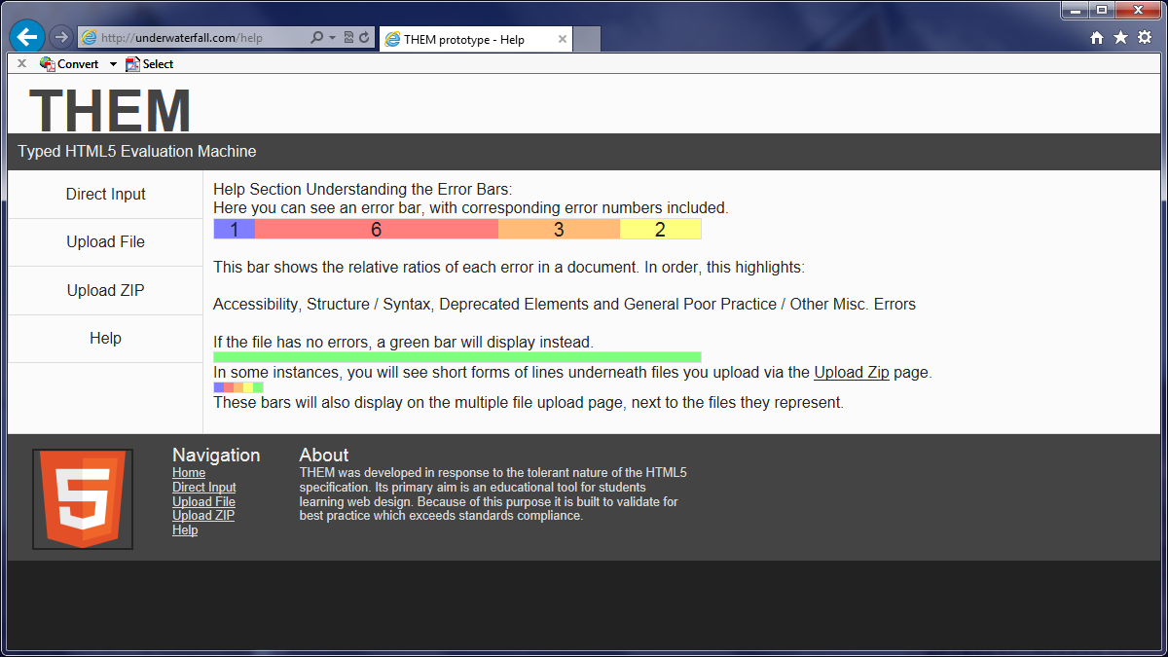
Get Informed
1. From the Home page, navigate to the Help page.
2. Read help information!

